Use Case Realisation Report - Manage Project
FOR
Volunteer Management System
(VMS)

CLIENT
PROJECT | Volunteer Management System (VMS)
TITLE | Use Case Realisation Report - Manage Project
VERSION | 0.1a
DATE | 13-Aug-2011
 | ORIGINATOR
 | Name / Signature | Team 8S
 | APPROVAL
 | Name / Signature | Phung Kim Cuong, Dio
Institute of Systems Science |  | Document Reference
25 Heng Mui Keng Terrence  Singapore 119615 |  | VMS/PM-1.3.1/1

 | Acceptance
 | Customer Signature |  | Customer Signature
 | Name & Designation |  | Name & Designation
 | Date & Company Stamp |  | Date & Company Stamp

Revision History

Date | Version | Description | Author
12-Jun-2011 | 0.1a | Creation | Team 8S
 |  | Refer to amendment history

Table of Contents

Use Case Realisation Report - Manage Project 3
1. Brief Description 3
2. Flow of Events 3
2.1 Standard Flow 3
2.1.1 List Project 3
2.1.2 Search Project 3
2.1.3 Create Project 4
2.1.4 Update Project 4
2.2 Exceptions 5
3. Interaction Diagrams 5
3.1 Login / Logout 5
4. Participating Objects 5
5. Class Diagrams 5
6. Derived Requirements 5
ANNEX D Amendment History 7

Use Case Realisation Report - Manage Project

Brief Description
The use case enables the Project Manager to perform management of project sites that he is in-charge of.

Flow of Events
The standard flow of events for this use case and any exceptions are described in the following subsections. See section 3.1 for an overview of the participating Actors and Domain Objects.

Standard Flow
Precondition: User has logged in the system.
This use case provides the user interface related functionality that will be provided to the Project Manager for interaction with regards to project management, as follows:

List Project
- The use case starts when the Project Manager selects the project option from the system.
- The system will pre-populate Project Listing Screen with a list of projects that the Project Manager is in-charge of. The list of projects information is populated from Project and User object.
- The Project Manager is then displayed with the Project Listing Screen.
- The use case terminates.

Search Project
- The use case starts when the Project Manager selects the search project option from the system.
- The Search Project Screen is displayed.
- The Project Manager provides a number of criteria for the project into the Search Project Screen and submits the form. The search criteria includes the project name, country, location, start date, project status and project manager. The system will display a list of country as a selection list by retrieving the information of the Country. The system will also display a list of project status as a selection list by retrieving the information of the project status.
- The Search Project Screen will use the provided information to retrieve a list of Project that matches the criteria.
- The Search Project Screen will perform the following actions:
  - Retrieve the information of the Project object.
  - Retrieve the information of the Project Manager who is the in-charge of the Project using the User object.
- The Search Project Screen will present the Project Manager with the Project Listing Screen where it will display the project name, country, start date, project status and project manager in the listing. The project name will be hyperlinked for the Project Manager to select to view more details about the Project.
- The use case terminates.

Create Project
- The use case starts when the Project Manager selects the create project option from the system.
- The Create Project Screen is displayed.
- The Project Manager provides all the required information concerning a new project into the Create Project Screen.
- The system performs validation for the input fields.
- If the validation passed, the existence of the new project in the system is checked against the project information held by the Project object.
- If the new project is not existent, the project record is created with the supplied details along with User information from object User and the current date from the object Date. The new project information is held by the object Project. The system displays an informational message for successfully updated message in the Create Project Screen.
- The use case terminates.

Update Project
- The use case starts when the Project Manager selects a record to update from the Project Listing Screen. To select a record to update, this is achieved through the List Project or Search Project use cases.
- The Update Project Screen is displayed with pre-populated details. The information are retrieved from Project and User objects.
- The Project Manager provides all the required information concerning the project into the Update Project Screen.
- The system performs validation for the input fields.
- If the validation passed, the project record is updated with the updated details along with User information from object User and the current date from the object Date. The updated project information is held by the object Project. The system displays an informational message for successfully updated message in the Update Project Screen.
- The use case terminates.

Exceptions
The following exceptions were identified:
- Validation fails. If any of the input is incorrect, the project creation fails. An error message is displayed in the Create Project Screen.
- New project exists. If the new project is found to be an existing one, the project creation fails. An error message is displayed in the Create Project Screen.
- Validation fails. If any of the input is incorrect, the project update fails. An error message is displayed in the Update Project Screen

Interaction Diagrams

Login / Logout
This use case allows the user to login and logout of the system when he wishes to use the system or to exit from using the system.

Participating Objects

Class Diagrams

Derived Requirements

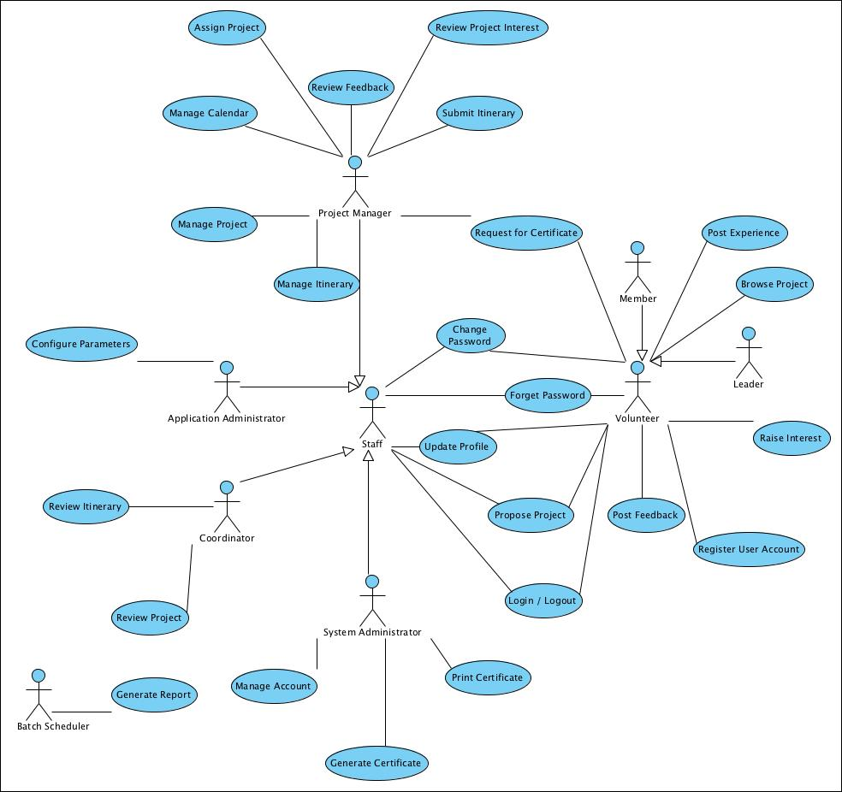

ANNEX D Amendment History

This is a record of all amendments made to the Document.
Version | Chapter / Section | Page No | Notes of Amendments or Changes

